**GCSI Procedure Room Recording System Instructions for Use**

**Introduction:**

This document provides a detailed overview of how different user groups (administrators, students, and educational facilitators) should utilize the GCSI Procedure Room Recording System. The structure of these instructions is as follows:

* Administrator - before student recording, first-time set up (~20 min)
* Administrator - before student recording, subsequent set up (~5 min)
* Administrator - after student recording (~2 min)
* Administrator - troubleshooting tips
* Students
* Facilitators

**Features:**

The Recording System has the following features:

* Requires minimal input from students to record and save videos.
* Allows students to modify camera setup for different procedures.
* Saves video recordings as .mp4 for simple playback on most video players.
* Uses OBS Studio to allow for multiple camera angle streams.
* Automatically names video files using students’ information for easy sorting by administrators.
* Automatically deletes video recordings and student information from local storage after video is saved (prevents PII access between students).
* Automatically encrypts saved videos using 7-Zip, extractable only by administrators (prevents PII access between students).

**Materials:**

To use the Recording System, you will need the following:

* Computer with access to the Internet
* Multiple camera sources (webcams, iPads, etc.)

**Administrator - before student recording, first-time set up (~20 min):**

**Step 1: Open Windows administrator account**

1. Open password-protected Windows administrator account (see Figure 1).

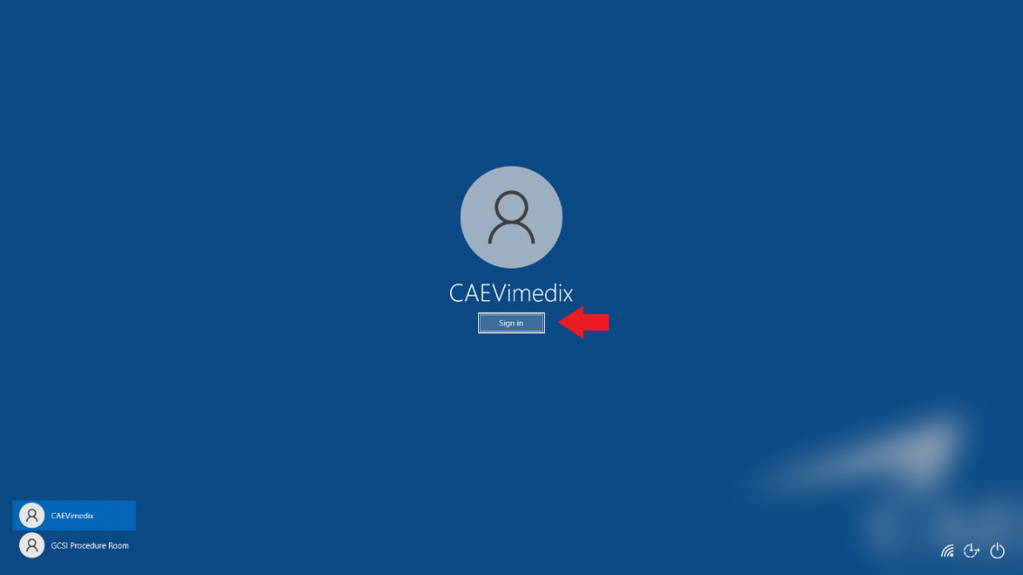

*Figure 1*: Windows administrator account sign-in

**Step 2: Download 7-Zip to computer C-Drive (C:\Program Files)**

1. Search for “7-Zip” on Google and download installer (see Figures 2 and 3).

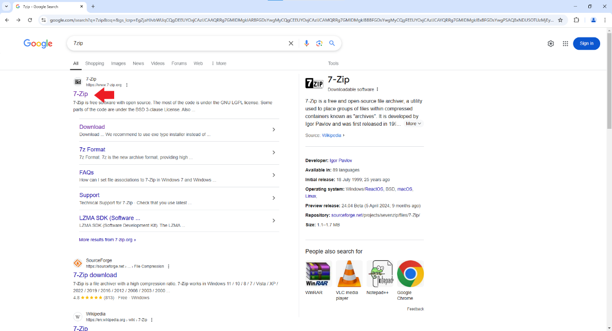

*Figure 2*: Google search for 7-Zip

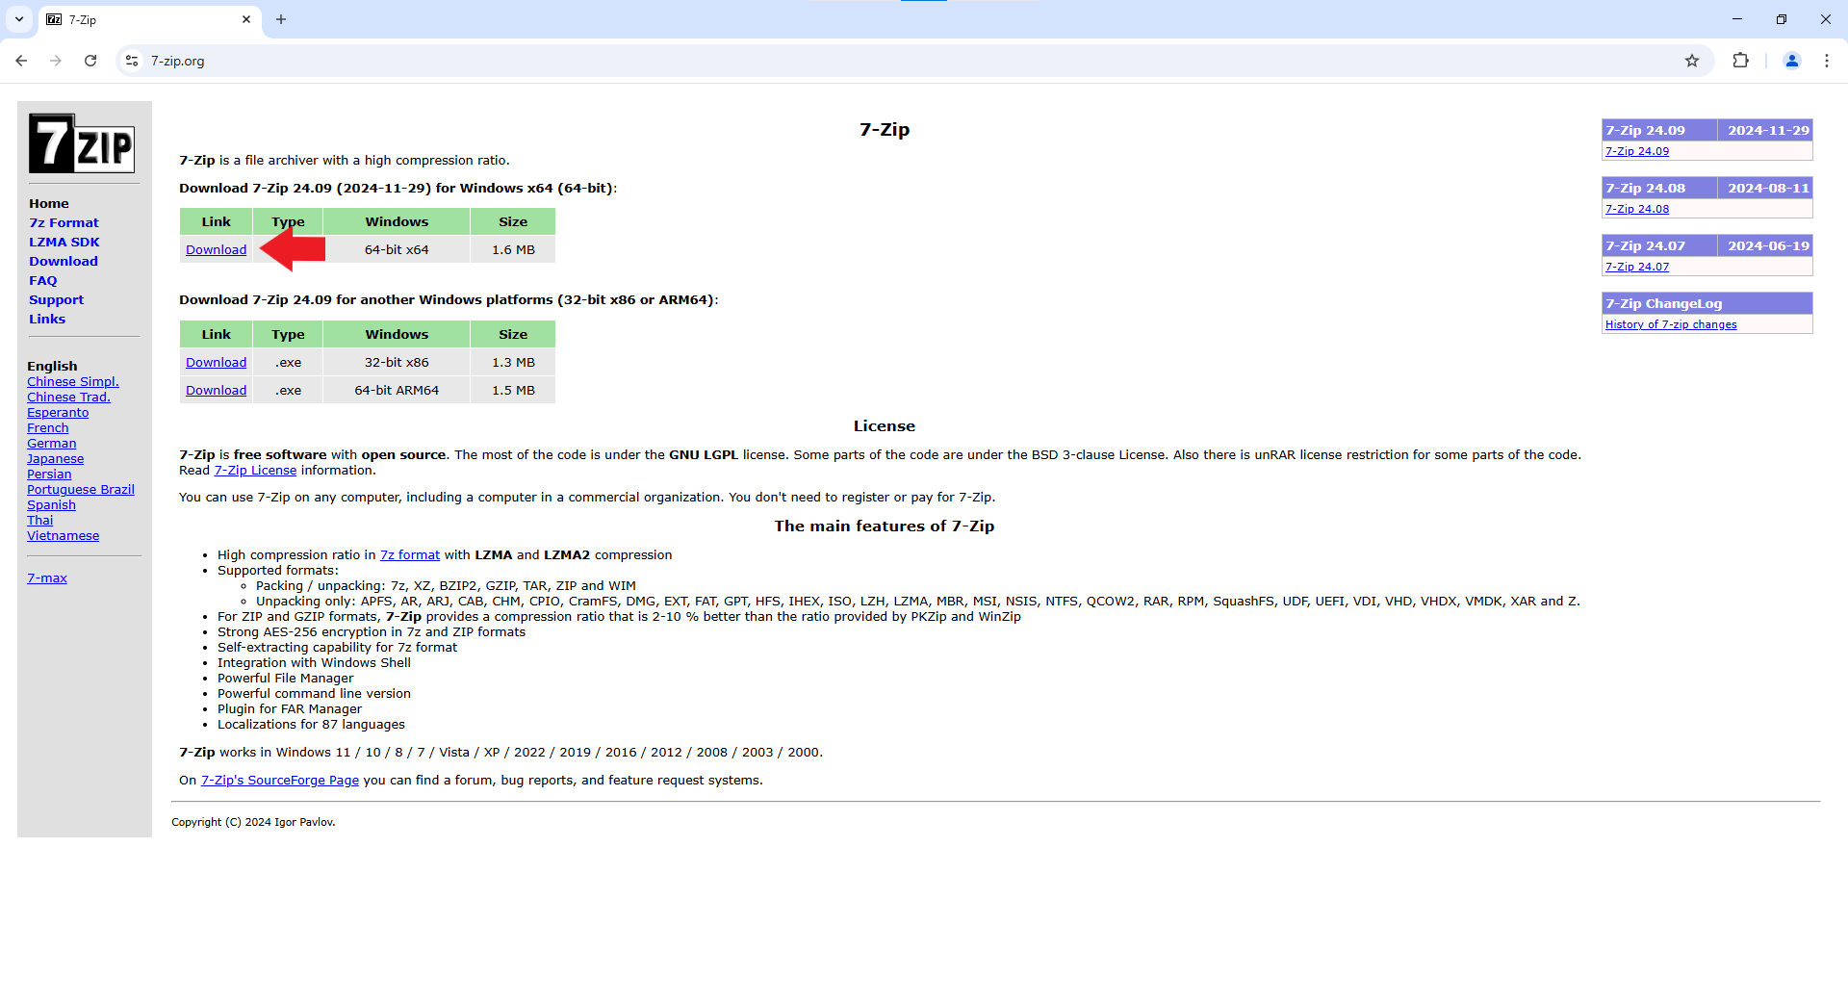

*Figure 3*: 7-Zip download link

1. Open File Explorer and double-click 7-Zip installer to download 7-Zip application to “C:\Program Files\7-Zip\” (see Figures 4 and 5).

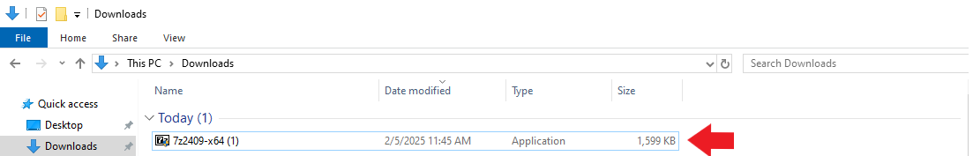

*Figure 4*: Double-click to open 7-Zip installer

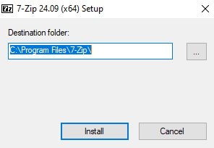

*Figure 5*: 7-Zip installer destination folder

1. Once installation is complete, ensure 7z.exe is in “C:\Program Files\7-Zip” (see Figure 6).

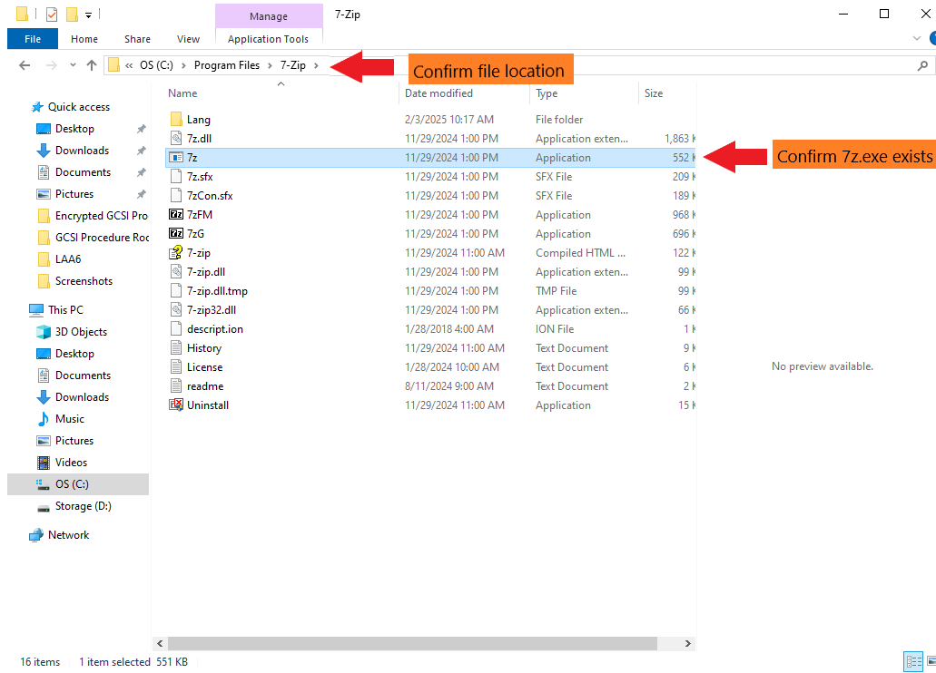

*Figure 6*: Confirm 7z.exe location

**Step 3: Set up necessary folders in File Explorer**

1. Create folder “C:\GCSI Procedure Room Downloads” (for students to directly upload videos to) in the computer C-Drive (see Figure 7).

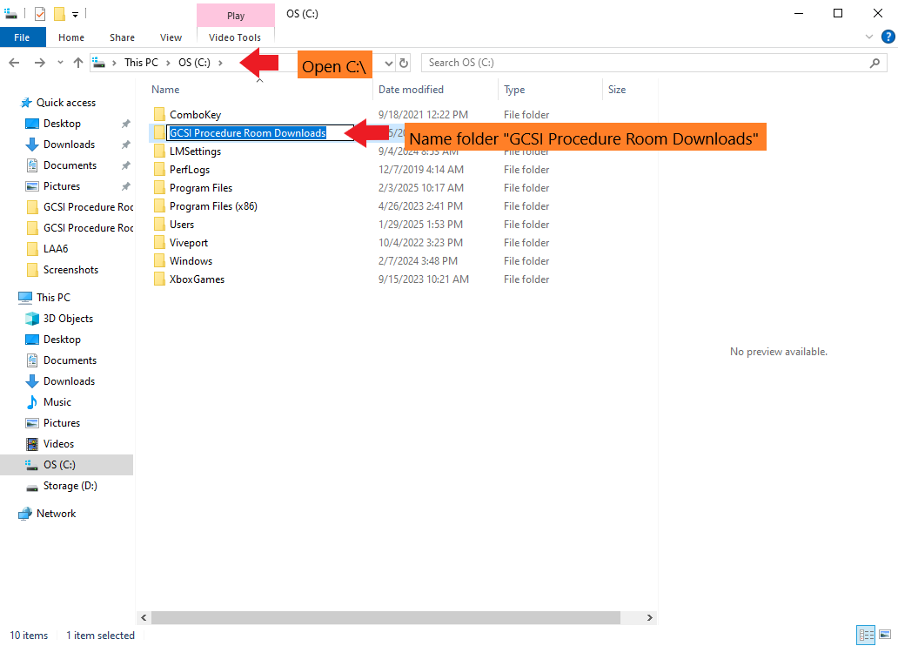

*Figure 7*: Create folder “C:\GCSI Procedure Room Downloads”

1. Create folder “C:\Encrypted GCSI Procedure Room Downloads” (for encrypted files, students will not be able to view files in this folder) in computer C-drive (see Figure 8).

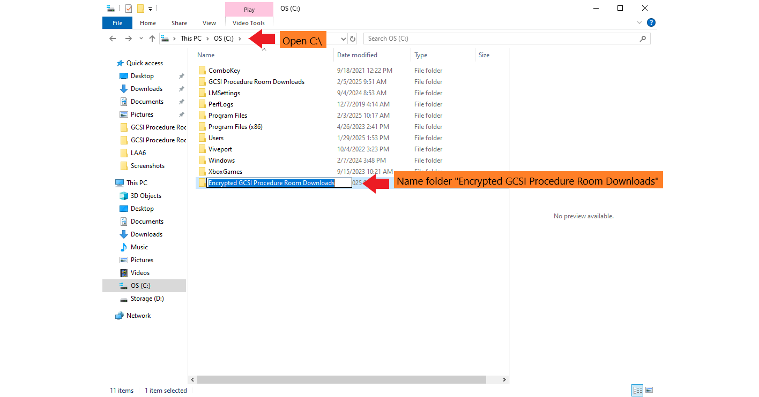

*Figure 8*: Create folder “C:\Encrypted GCSI Procedure Room Downloads”

1. Create folder “GCSI Procedure Room Encryption PowerShell” anywhere in administrator’s local document storage, but not in C-Drive (so a student using Windows guest account cannot access) (see Figure 9).

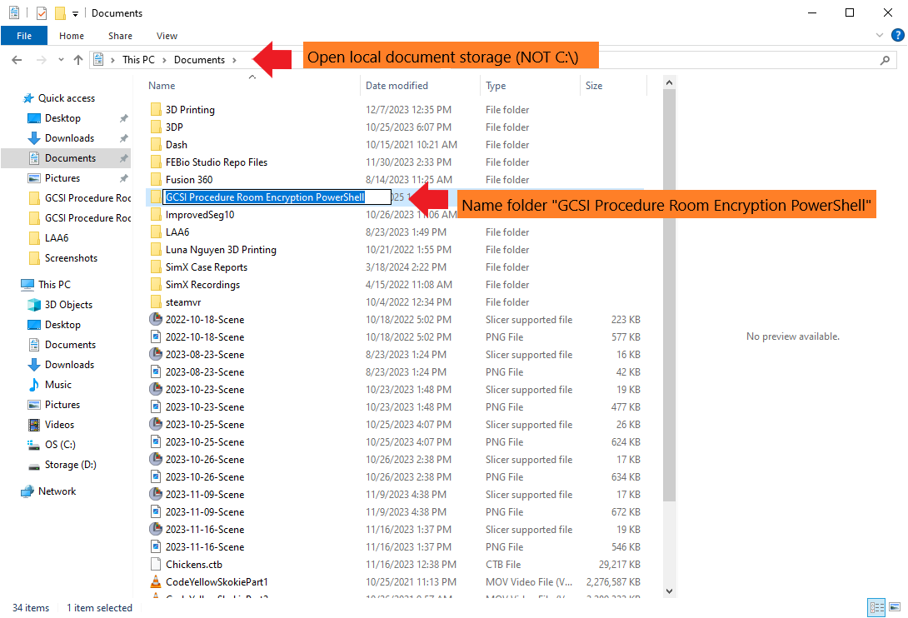

*Figure 9*: Create folder “GCSI Procedure Room Encryption PowerShell” in local documents

**Step 3: Set up PowerShell script for encryption of student recordings**

1. Navigate to <https://github.com/jchen6589/procedure-room-recording-v4> -> download “real_time_encrypt.ps1” -> move the file to the “GCSI Procedure Room Encryption PowerShell” folder.
   1. If necessary, open “real_time_encrypt.ps1” in Notepad to adjust the password and the path to the source folder (for students to directly upload videos to), the destination folder (where encrypted files will go), and 7z.exe as needed (see Figure 10). If folder names and locations are created exactly according to the previous steps, no adjustment should be necessary.
   2. When the “real_time_encrypt.ps1” PowerShell script is running, it will continuously scan for new files in “C:\GCSI Procedure Room Downloads”, encrypt them using 7-Zip, place the encrypted file in “C:\Encrypted GCSI Procedure Room Downloads”, and delete the original file.

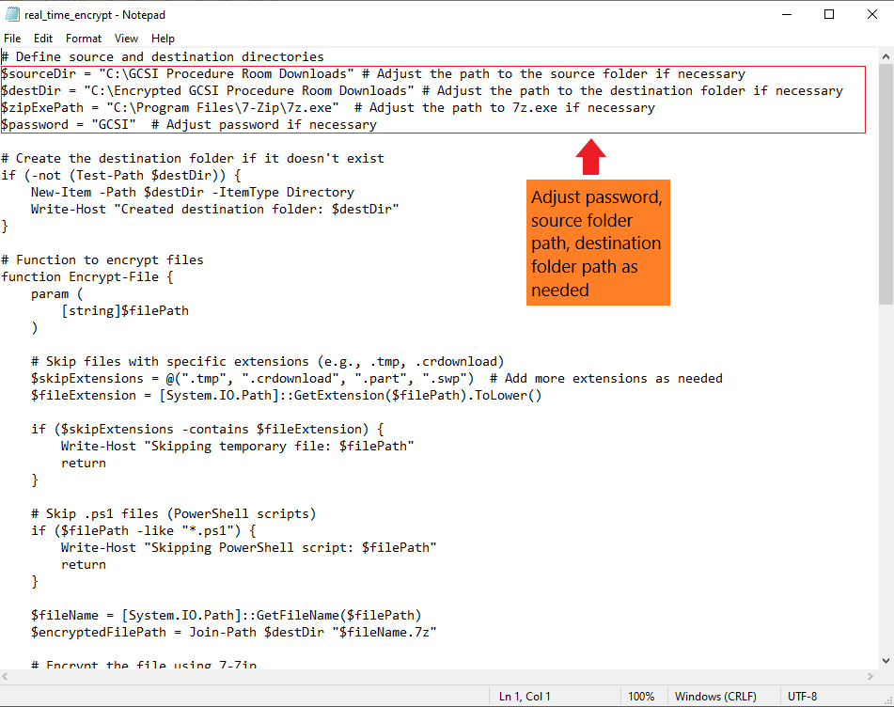

*Figure 10*: Create “real_time_encrypt.ps1” file in the “GCSI Procedure Room Encryption PowerShell” folder

1. Create a shortcut to start PowerShell script on desktop (see Figures 11-13).
   1. Go to the computer Desktop -> right-click -> New -> Shortcut.
   2. For location of the item, write C:\Windows\System32\WindowsPowerShell\v1.0\powershell.exe -ExecutionPolicy Bypass -NoExit -File "C:\GCSI Procedure Room Encryption PowerShell\real_time_encrypt.ps1"
   3. Adjust path to “real_time_encrypt.ps1” as needed. If folder names and locations are created exactly according to the previous steps, no adjustment should be necessary.
   4. For shortcut name, write “Start Real Time Encrypt”

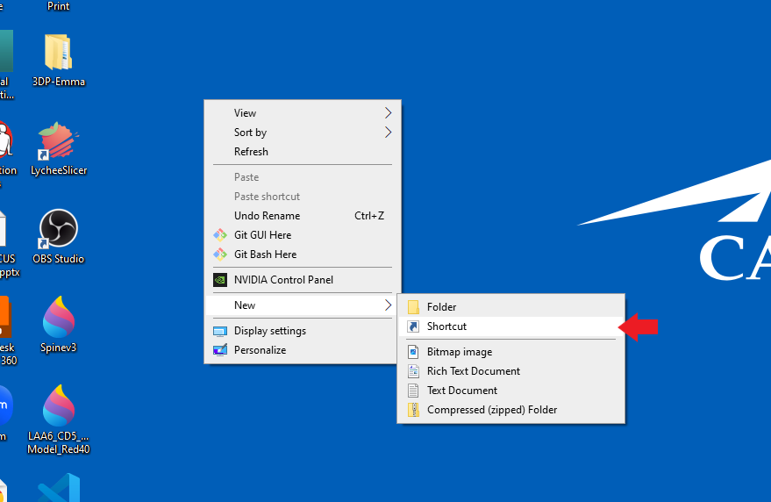

*Figure 11*: Create new shortcut on computer Desktop

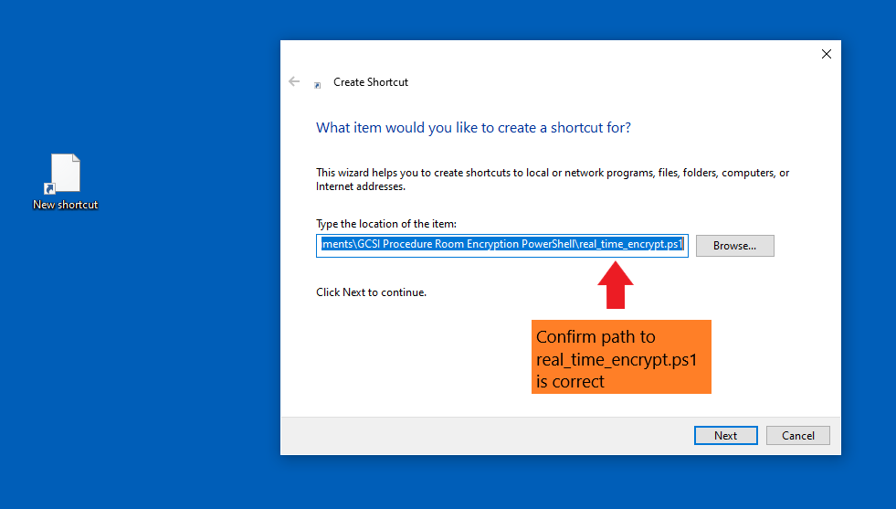

*Figure 12*: Set shortcut location as C:\Windows\System32\WindowsPowerShell\v1.0\powershell.exe -ExecutionPolicy Bypass -NoExit -File "C:\GCSI Procedure Room Encryption PowerShell\real_time_encrypt.ps1"

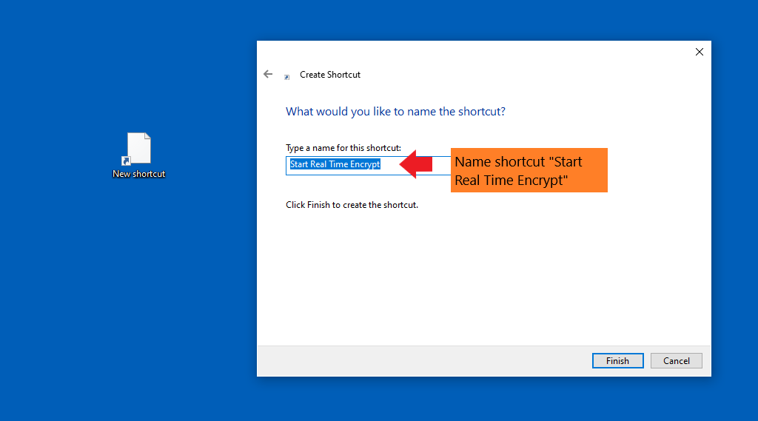

*Figure 13*: Set shortcut name as “Start Real Time Encrypt”

1. Double click shortcut to start running the “real_time_encrypt.ps1” script (see Figure 14). This shortcut will allow manual startup of the “real_time_encrypt.ps1” script (can also configure “real_time_encrypt.ps1" PowerShell script to start automatically on boot).

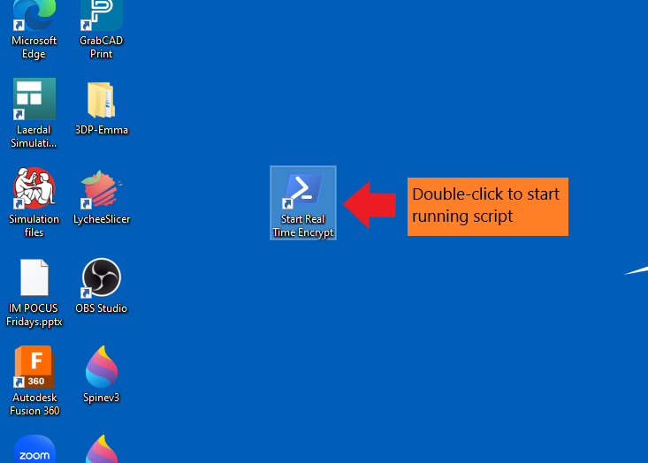

*Figure 14*: Start running script

**Step 4: Close Windows administrator account and open Windows guest account (local user)**

1. Create and open Windows guest account (see Figure 15).

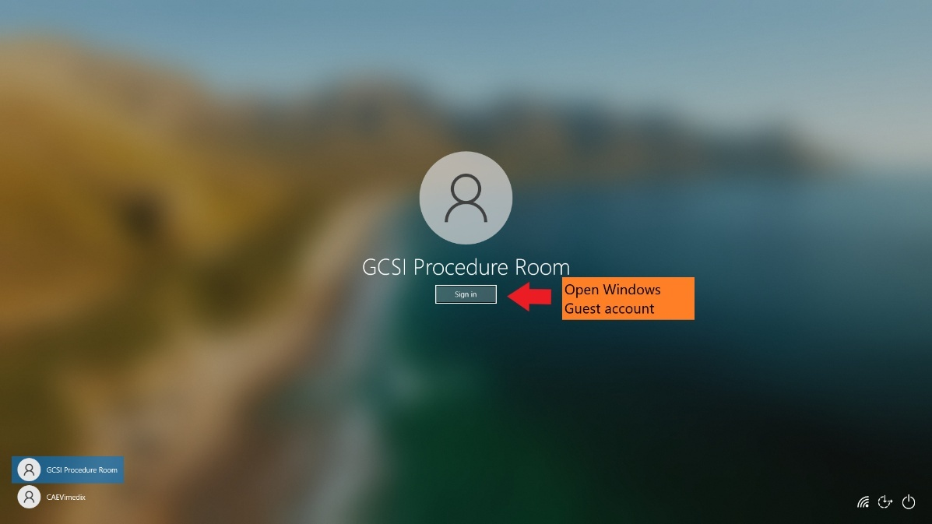

*Figure 15*: Windows guest account sign-in

**Step 5: Download OBS Studio**

1. Search for “OBS” on Google and download installer (see Figures 16 and 17).

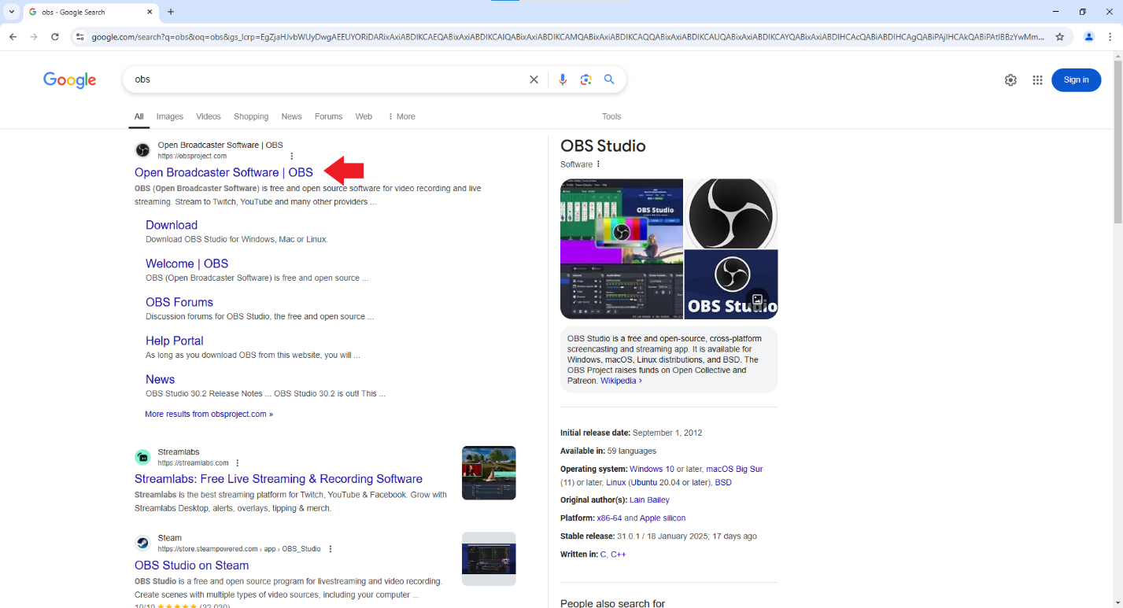

*Figure 16*: Google search for OBS

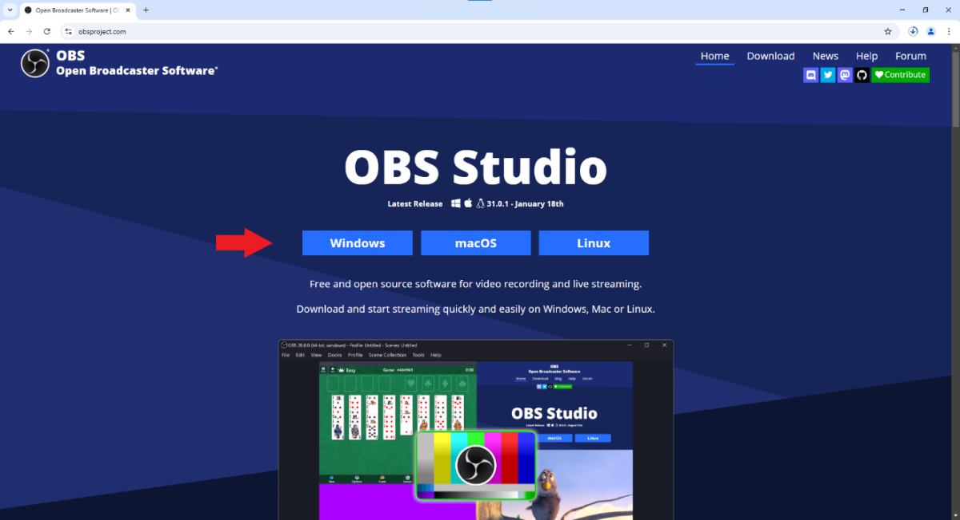

*Figure 17*: OBS Studio download link

1. Open File Explorer and double-click OBS Studio installer to install OBS Studio application (see Figure 18).

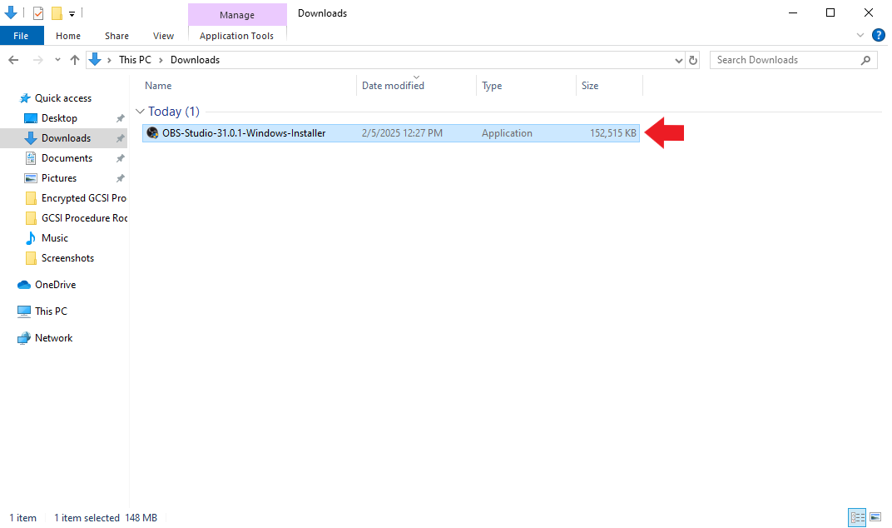

*Figure 18*: Double-click to install OBS Studio

**Step 6: Set up OBS Studio Virtual Camera**

1. Open OBS Studio (see Figure 19).

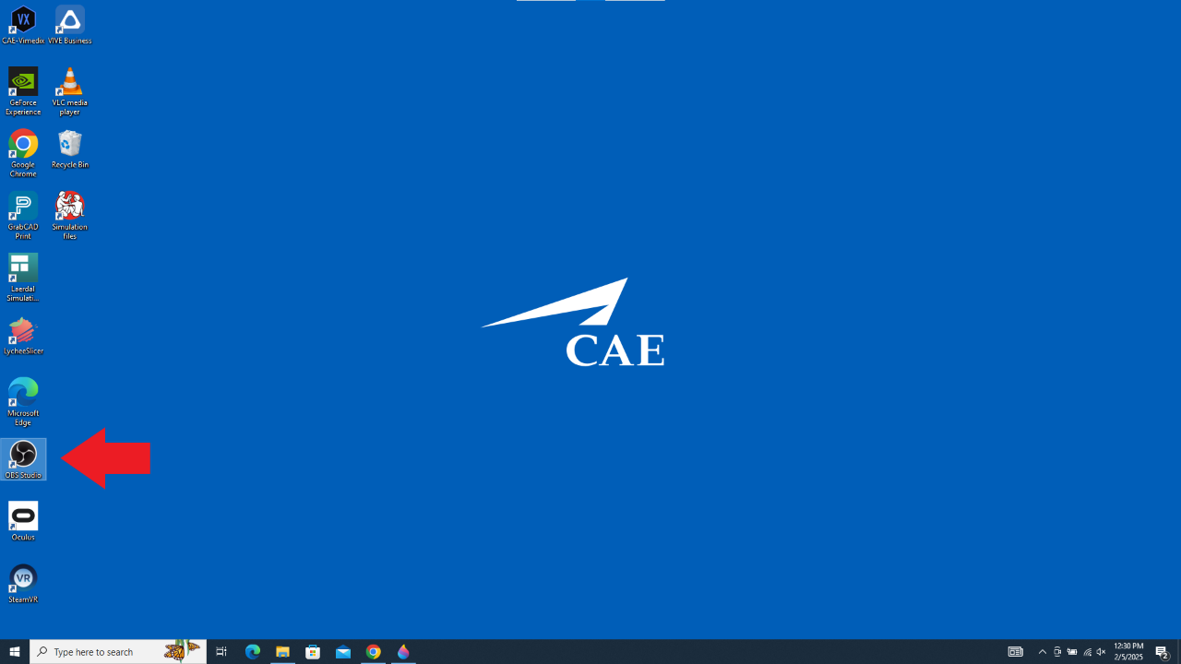

*Figure 19*: Open OBS from Desktop

1. Connect webcams to OBS:
   1. Sources -> Add Sources (+) -> Video Capture Device -> orient webcam streams in screen as desired -> add text box and place next to each stream to identify -> repeat for remaining webcams (see Figures 20-27).

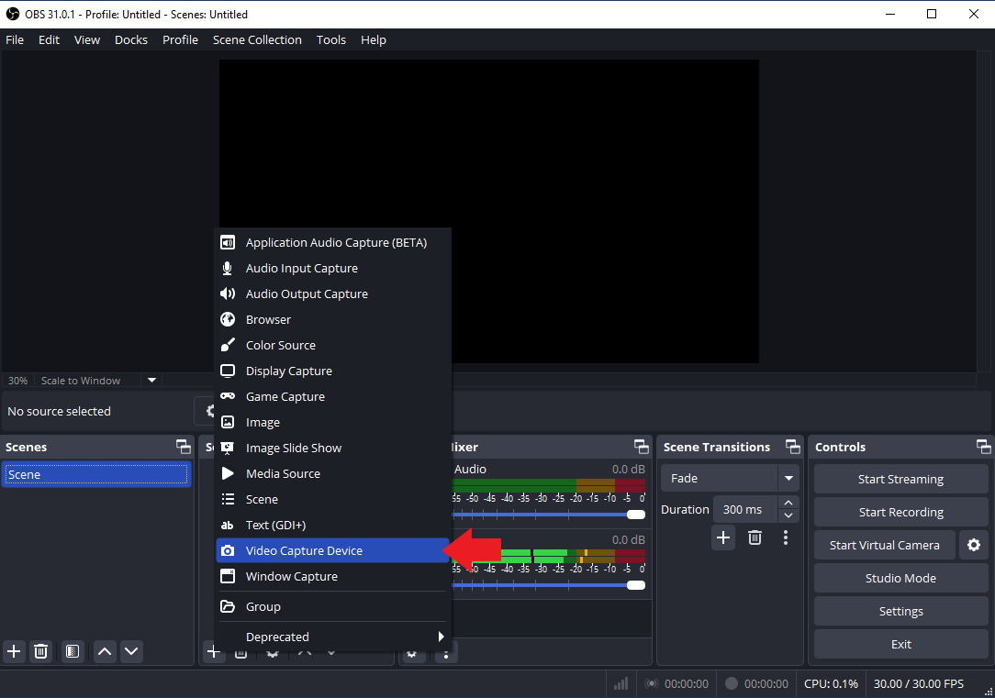

*Figure 20*: Create a Video Capture Device

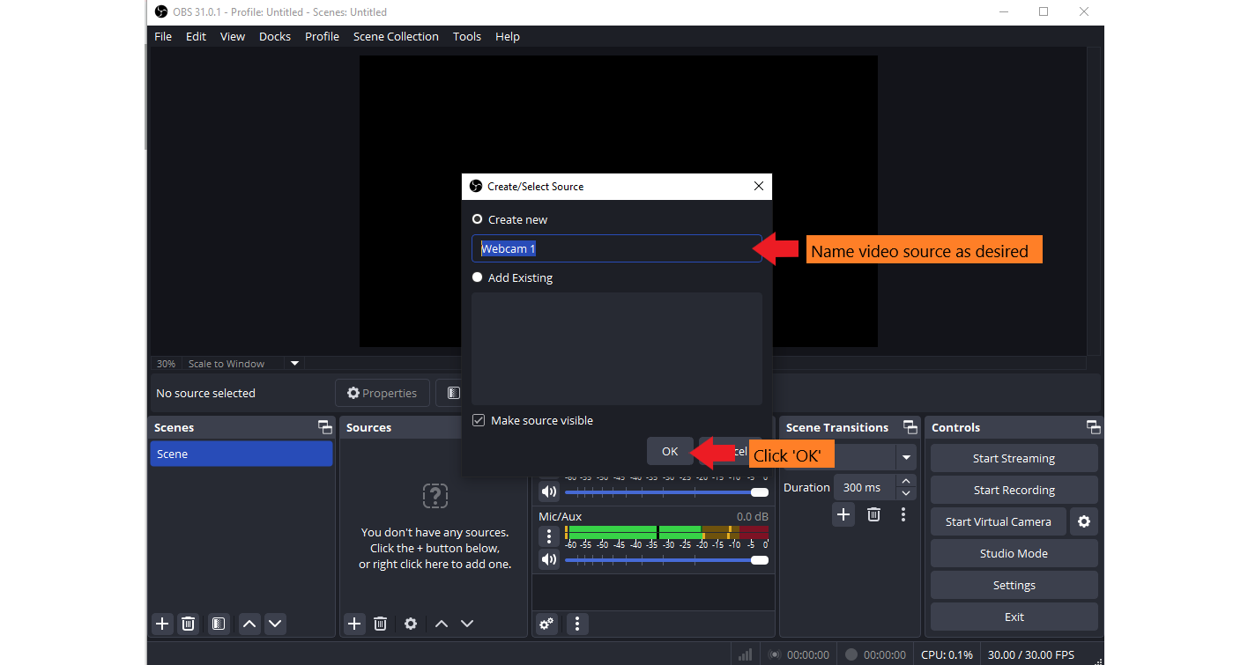

*Figure 21*: Create new video source

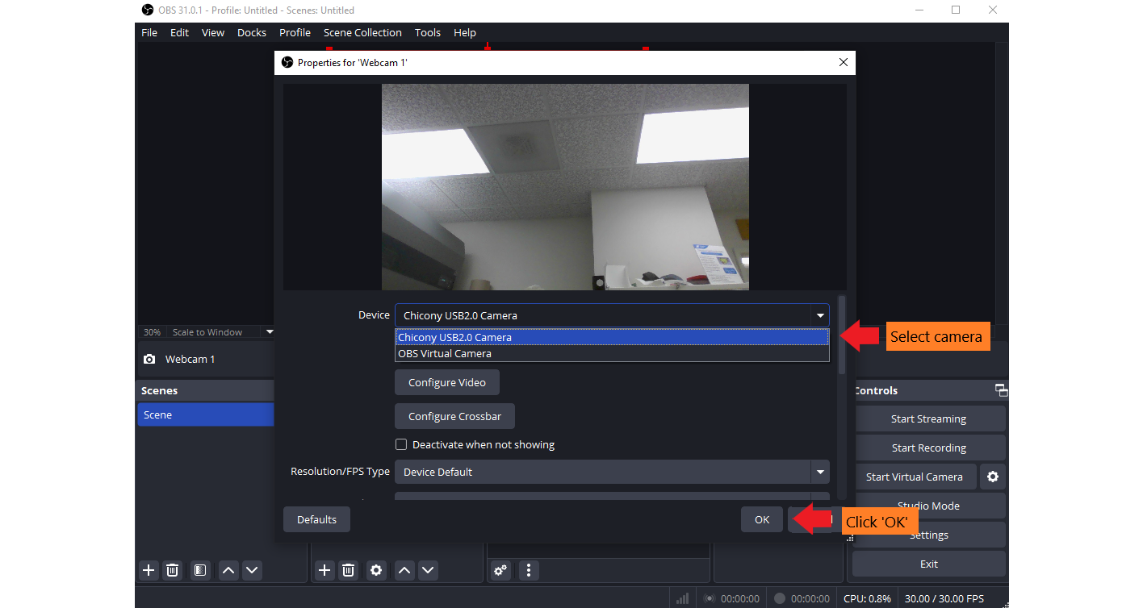

*Figure 22*: Select video source

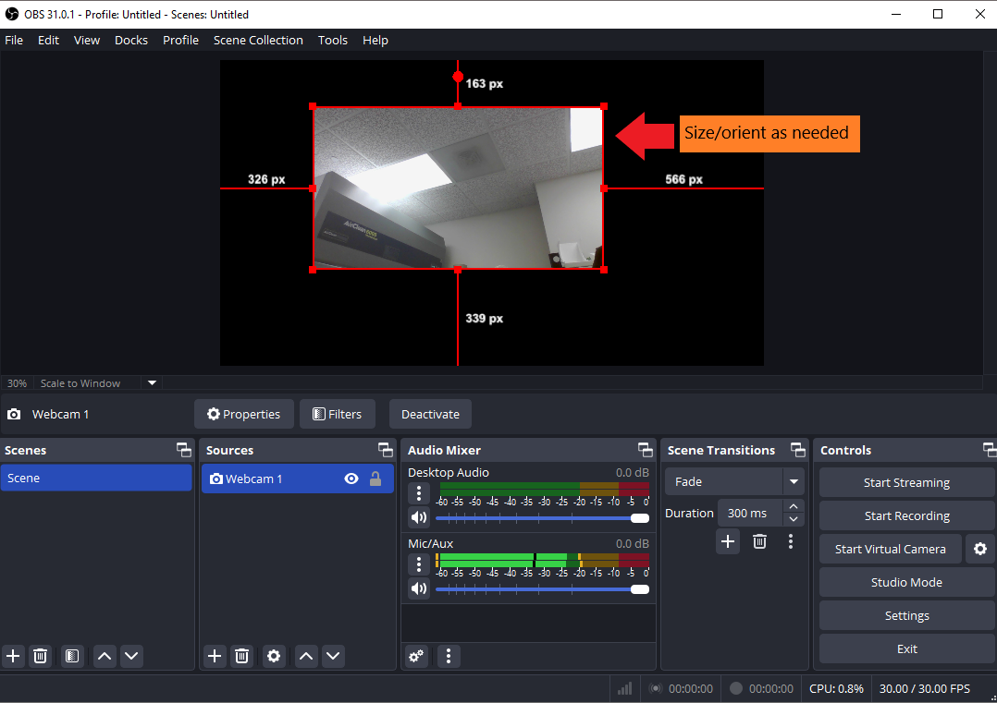

*Figure 23*: Size/orient webcam stream

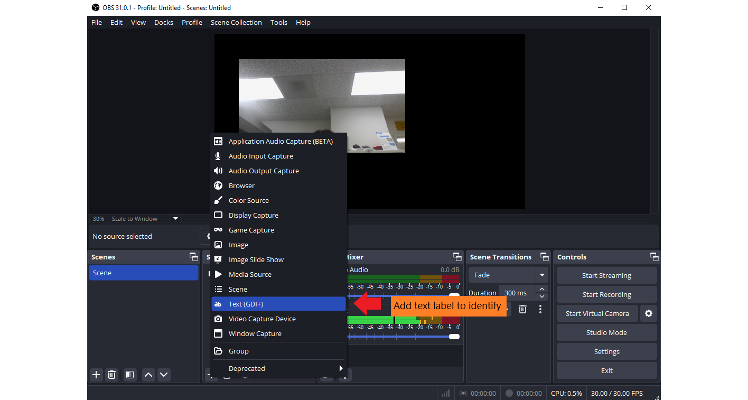

*Figure 24*: Create a Text label

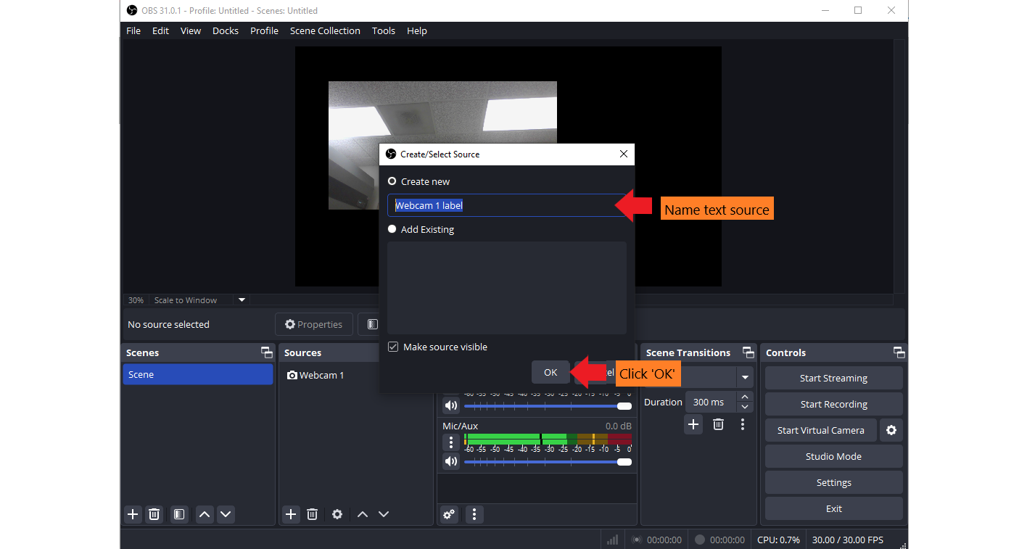

*Figure 25*: Create a new text source

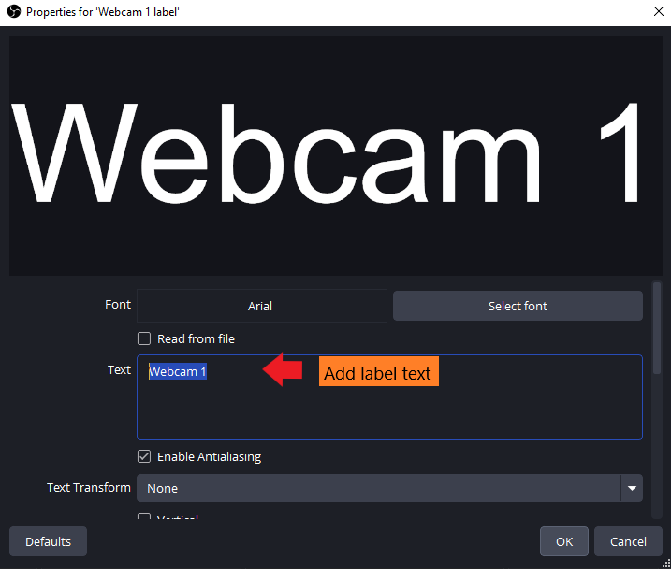

*Figure 26*: Add label text

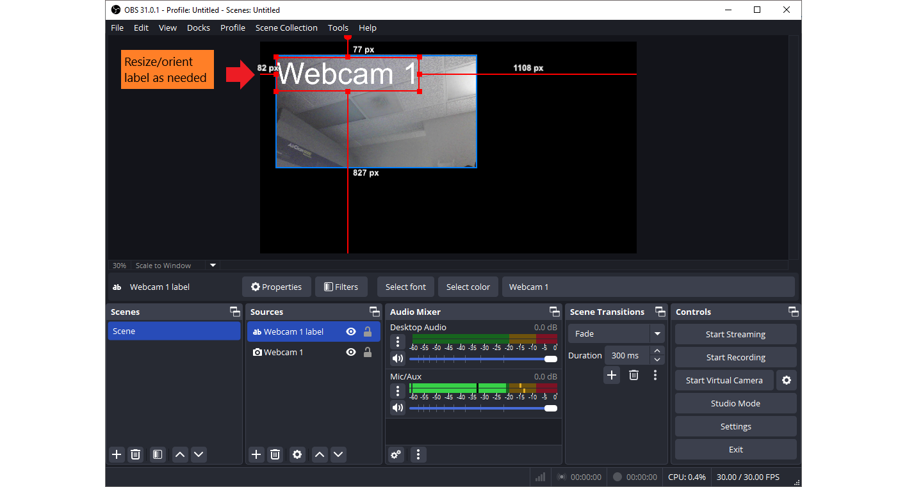

*Figure 27*: Size/orient text label

1. Connect iPad cameras to OBS (if necessary):
   1. In iPad Safari: Visit <https://vdo.ninja/> -> Add Your Camera to OBS -> Start -> mute iPad microphone -> copy unique VDO Ninja stream URL (see Figures 28-30).

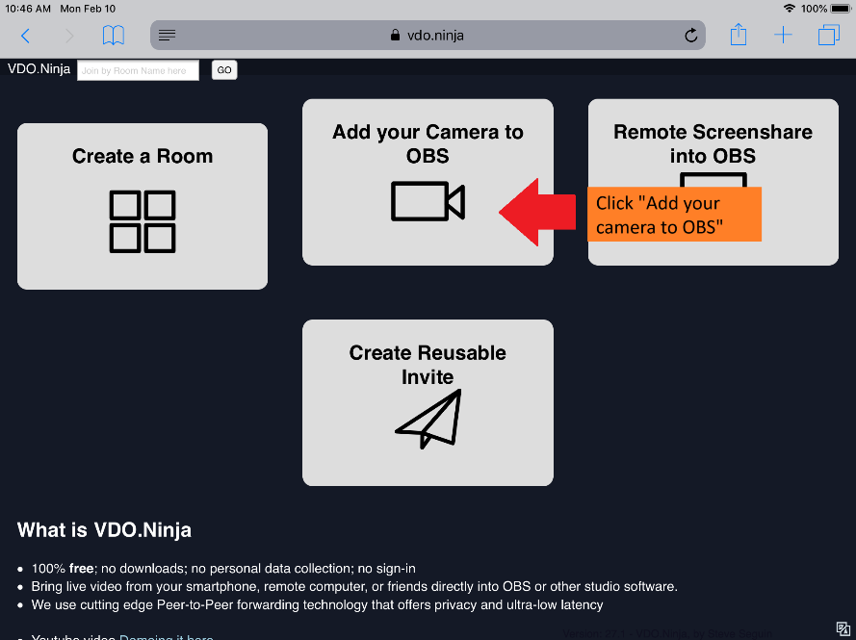

*Figure 28* : Open <https://vdo.ninja/> in iPad Safari and select “Add your camera to OBS”

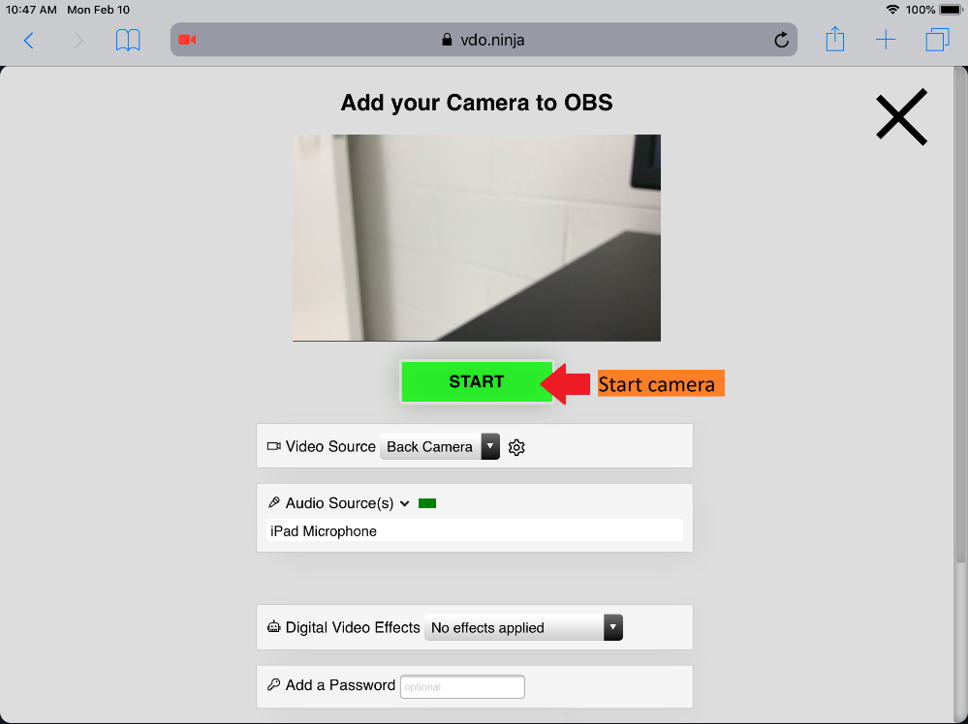

*Figure 29*: Start camera

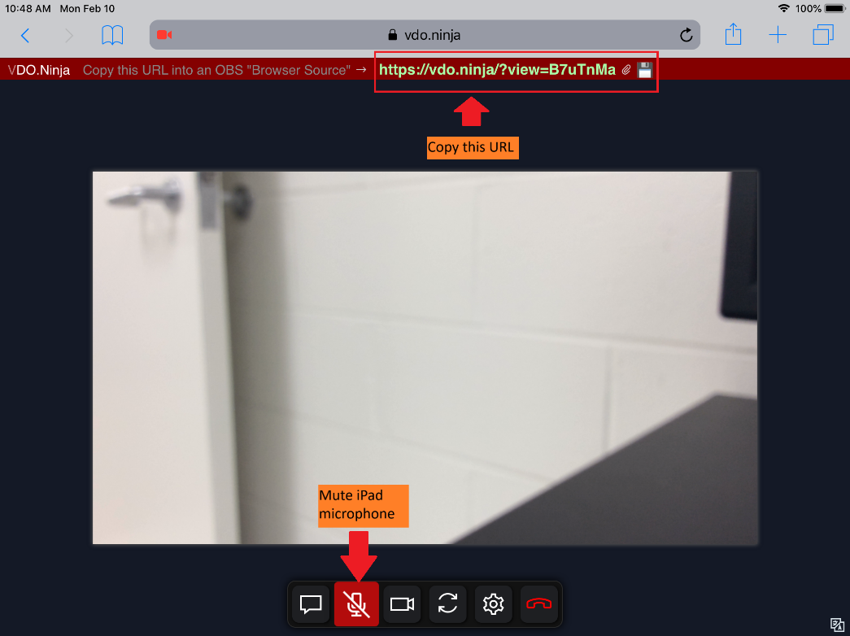

*Figure 30*: Mute iPad microphone and copy VDO Ninja URL

* 1. In OBS: Sources -> Add Sources (+) -> Browsers -> paste VDO Ninja URL -> add text box and place next to each stream to identify (see Figures 31-33 and 24-27).

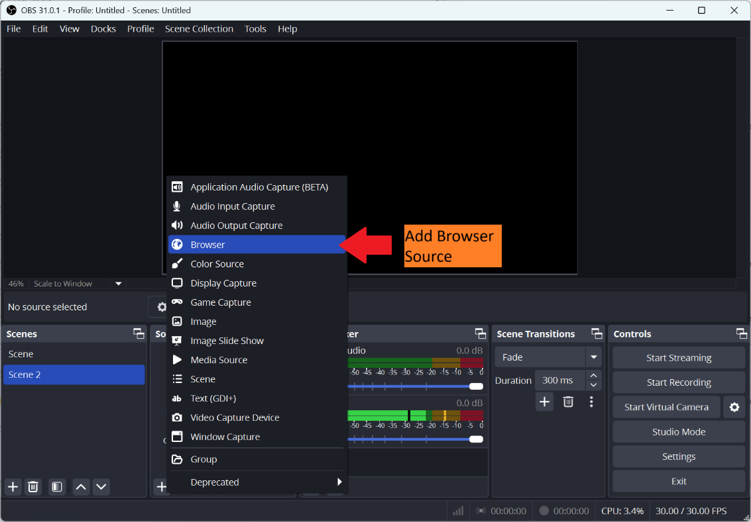

*Figure 31*: Add browser source

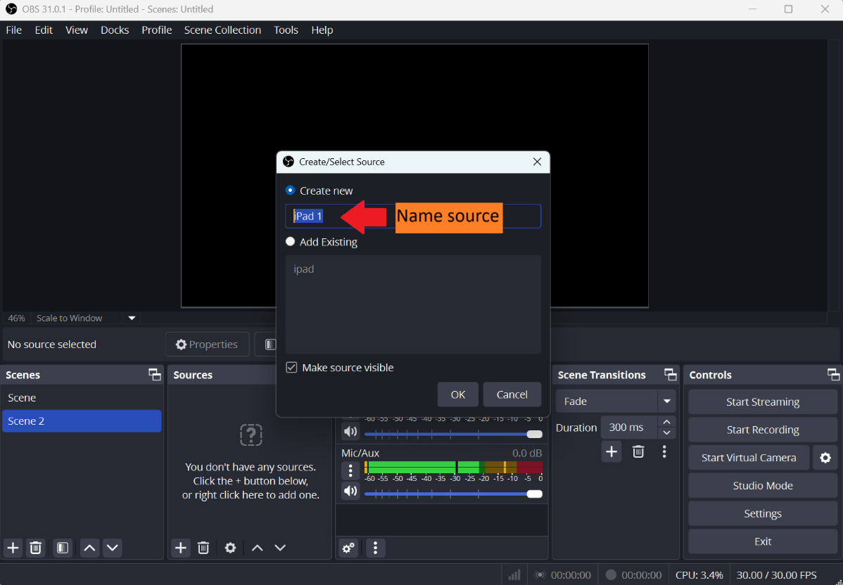

*Figure 32*: Name the browser source

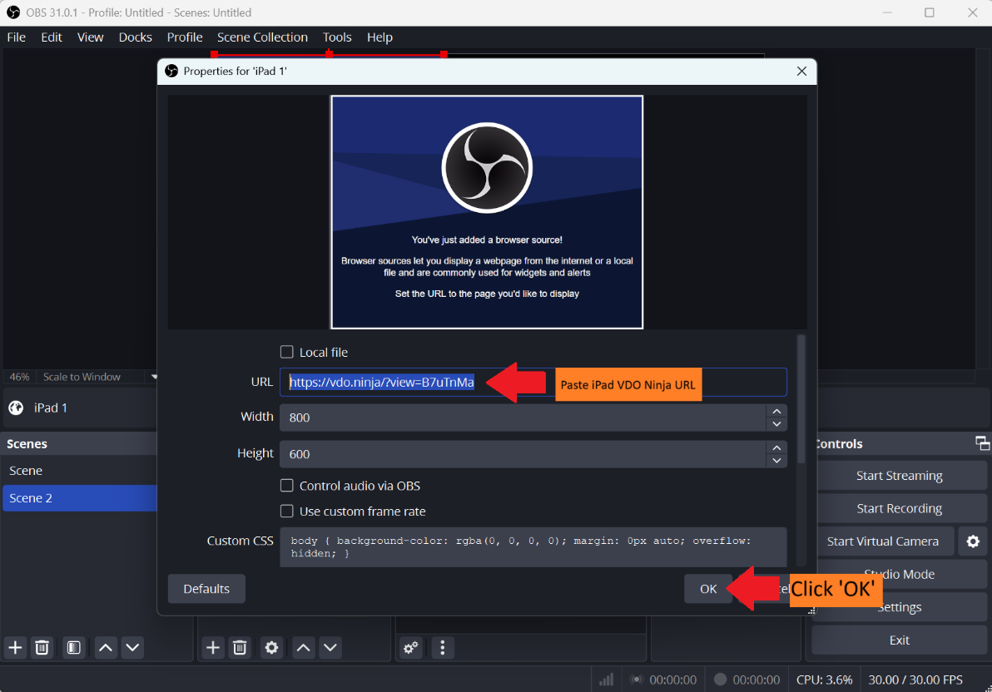

*Figure 33*: Paste iPad VDO Ninja URL to begin streaming

1. Click “Start Virtual Camera” (see Figure 34).

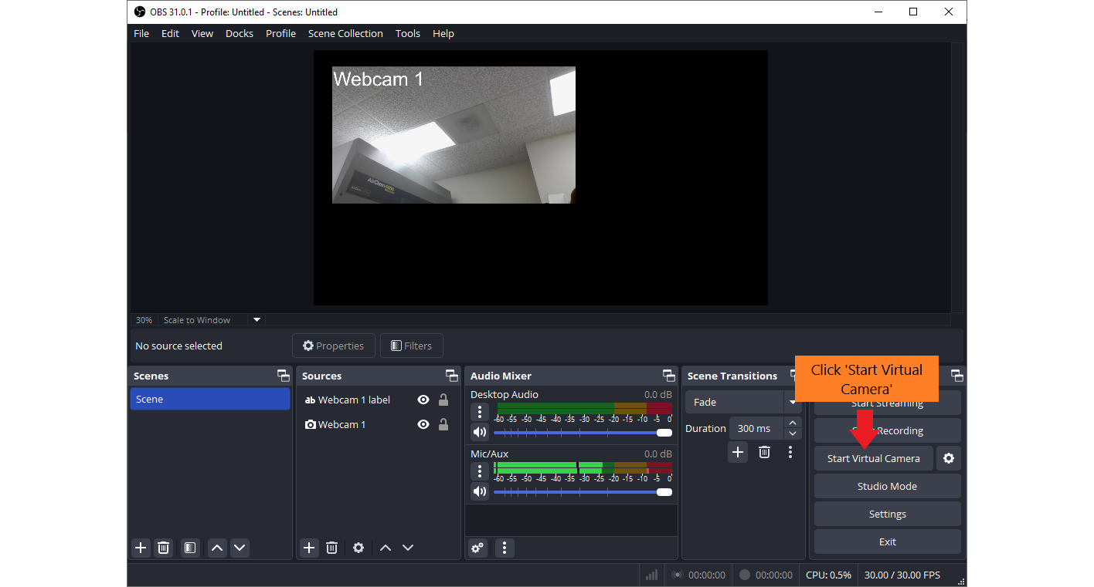

*Figure 34*: Start OBS Virtual Camera

**Step 7: Set up browser for student use**

1. Open Chrome/Edge browser settings (see Figure 35).

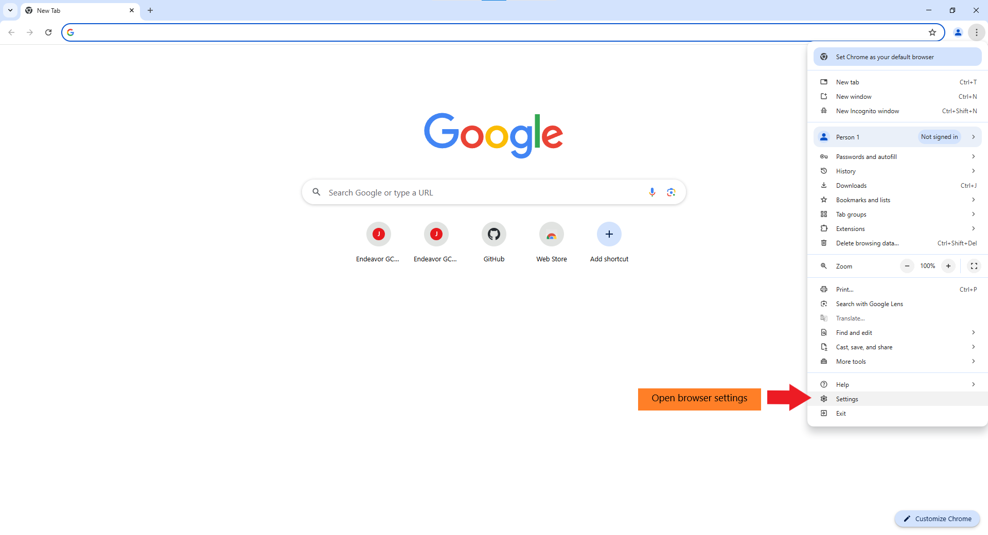

*Figure 35*: Open browser settings

1. Open privacy/security setting in Chrome/Edge window -> Site Settings -> Camera -> set camera to "OBS virtual camera" (see Figures 36-39).

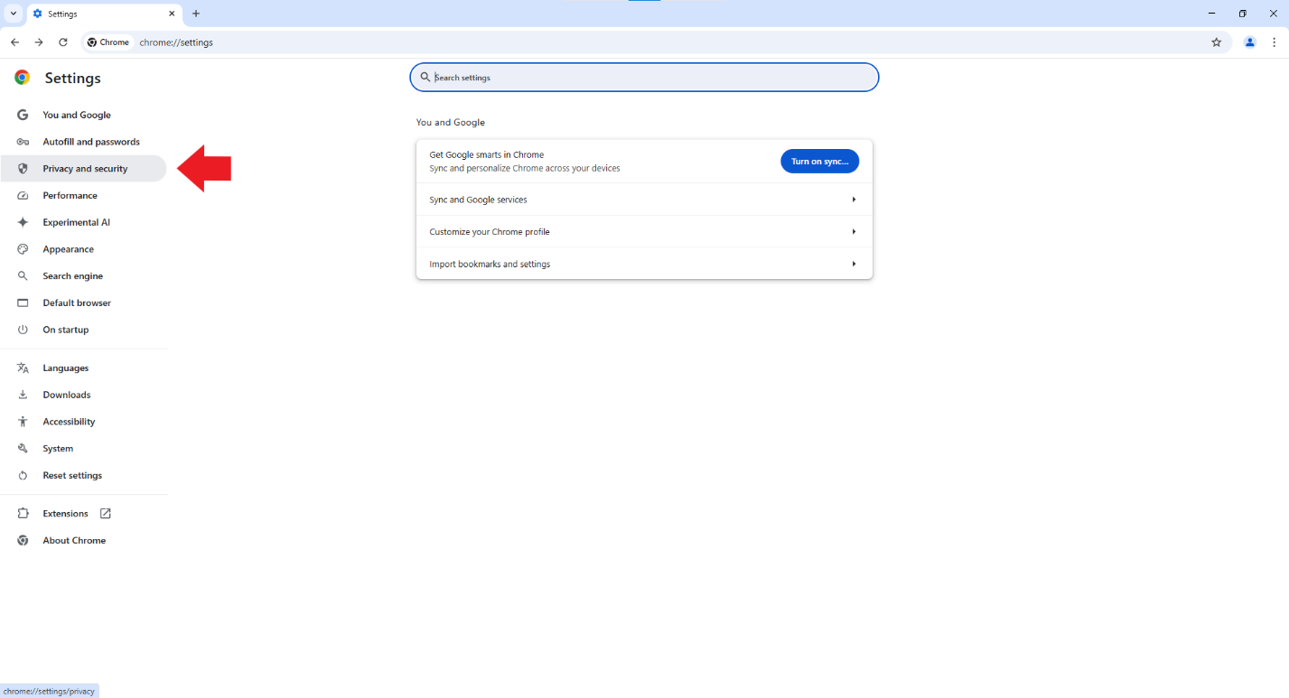

*Figure* 36: Open privacy/security settings

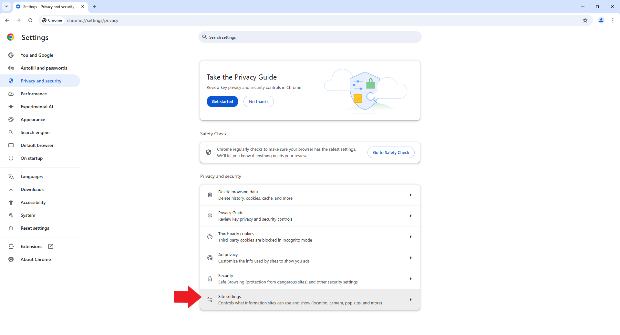

*Figure 37*: Open site settings

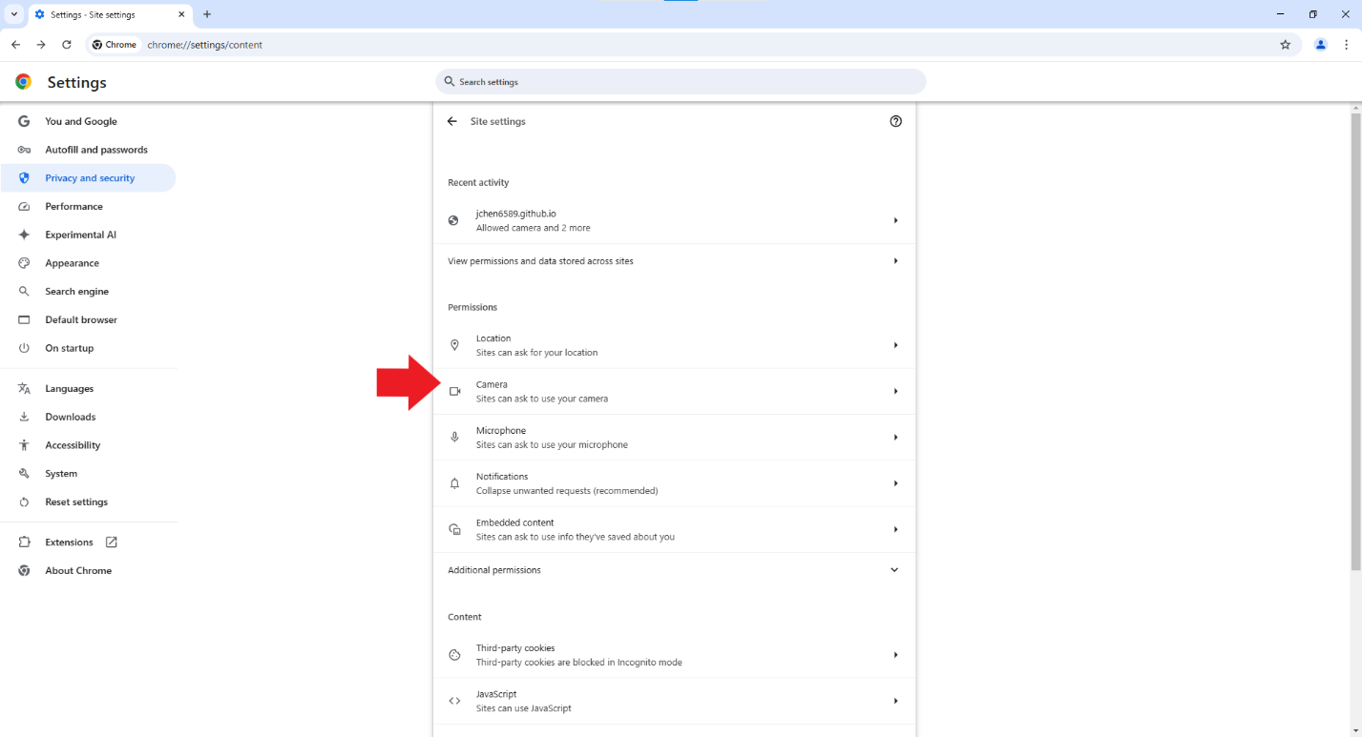

*Figure 38*: Open camera settings

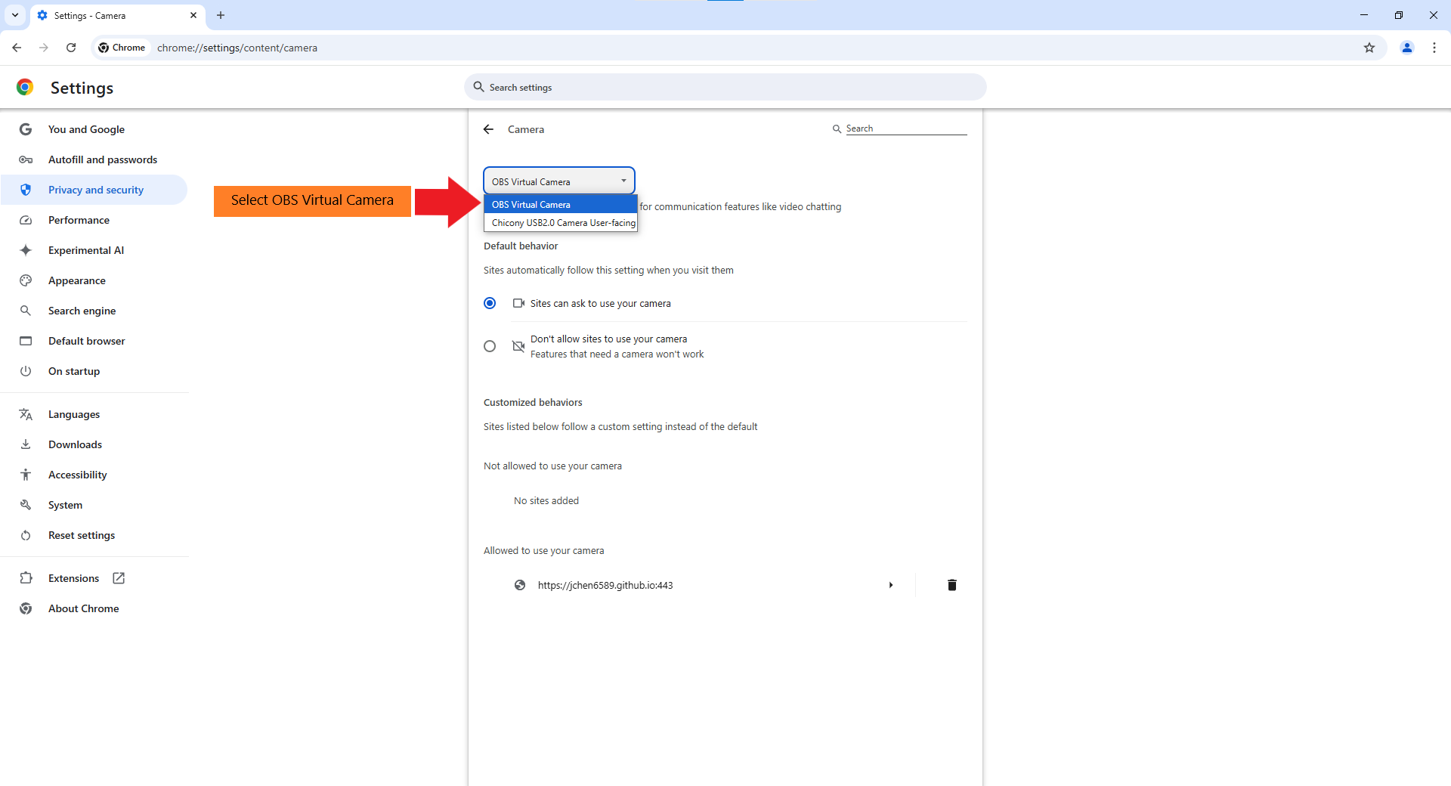

*Figure 39*: Select OBS Virtual camera

1. Open Downloads settings in Chrome/Edge window -> Set download folder to “C:\GCSI Procedure Room Downloads” (see Figures 40 and 41).

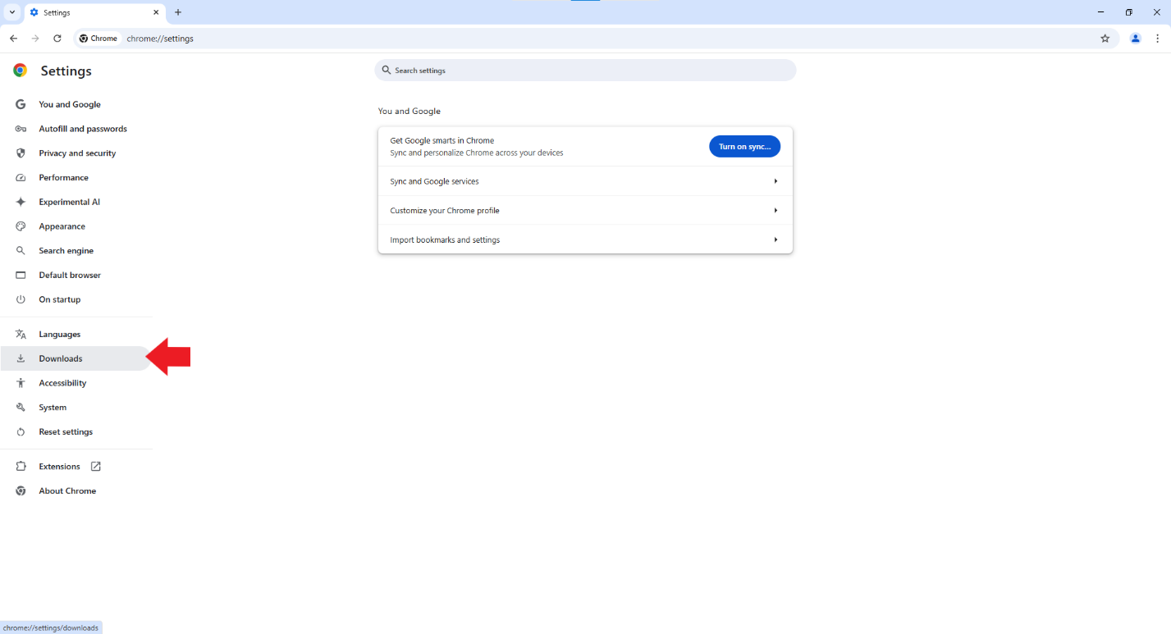

*Figure 40*: Open downloads settings

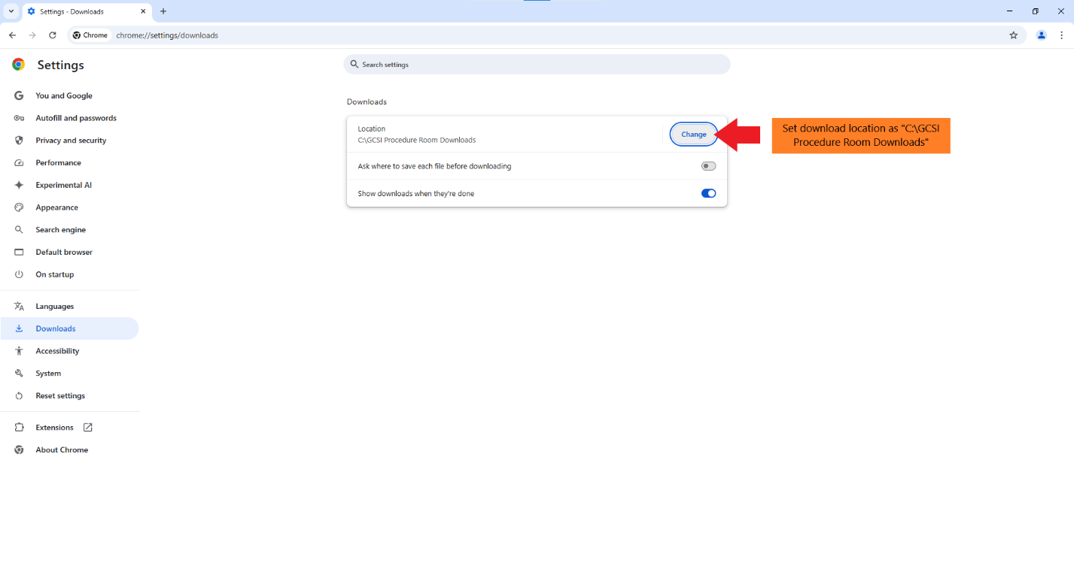

*Figure 41*: Set download folder to “C:\GCSI Procedure Room Downloads”

1. Open <https://jchen6589.github.io/procedure-room-recording-v4/>.
2. Leave website on start screen.

**Administrator - before student recording, subsequent set up (~5 min):**

**Step 1: Open Windows administrator account**

1. Open password-protected Windows administrator account (see Figure 42).

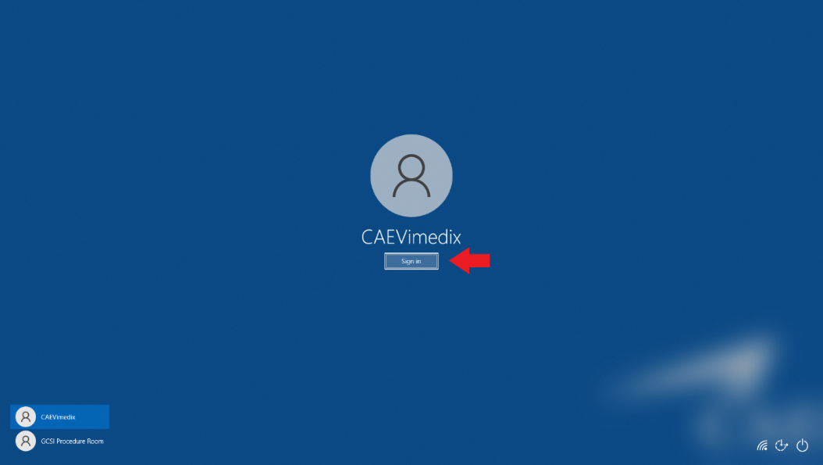

*Figure 42*: Windows administrator account sign-in

**Step 2: Start encryption PowerShell script**

1. Double click “Start Real Time Encrypt” shortcut to start running the “real_time_encrypt.ps1” script (see Figure 43).



*Figure 43*: Start running script

**Step 3: Close Windows administrator account and open Windows guest account (local user)**

1. Open Windows guest account (local user) (see Figure 44).

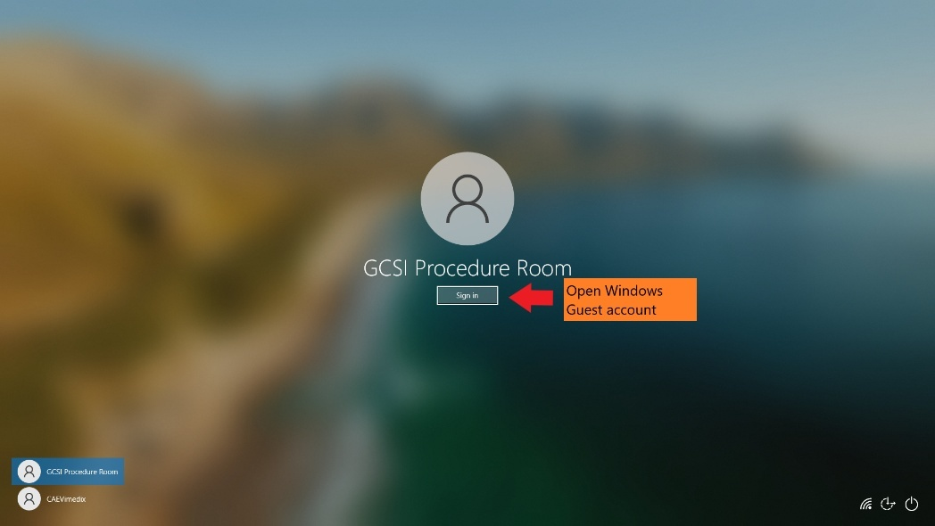

*Figure 44*: Windows guest account sign-in

**Step 4: Start OBS Virtual Camera**

1. Open OBS Studio.
2. Ensure all camera streams are running and labels are correct.
3. “Start Virtual Camera” in OBS (see Figure 45).



*Figure 45*: Start OBS Virtual Camera

**Step 5: Set up browser for student use**

1. Open Chrome/Edge window.
2. Open privacy/security setting in Chrome/Edge window.
3. Set camera to "OBS virtual camera" (see Figure 46).



*Figure 46*: Select OBS Virtual camera

1. Open Downloads settings in Chrome/Edge window.
2. Set download folder to “C:\GCSI Procedure Room Downloads” (see Figure 47).



*Figure 47*: Set download folder to “C:\GCSI Procedure Room Downloads”

1. Open <https://jchen6589.github.io/procedure-room-recording-v4/>
2. Leave webpage on start screen.

**Administrator - after student recording (~2 min):**

**Step 1: Open Windows administrator account**

1. Open password-protected Windows administrator account (see Figure 48).

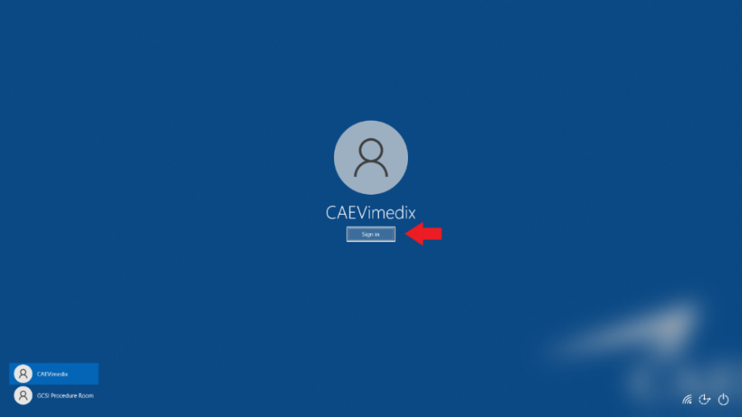

*Figure 48*: Windows administrator account sign-in

**Step 2: Extract encrypted student recordings**

1. Open “C:\GCSI Procedure Room Downloads”. Confirm original files have been deleted (see Figure 49). This folder should always be empty as long as the “real_time_encrypt.ps1” script is running.

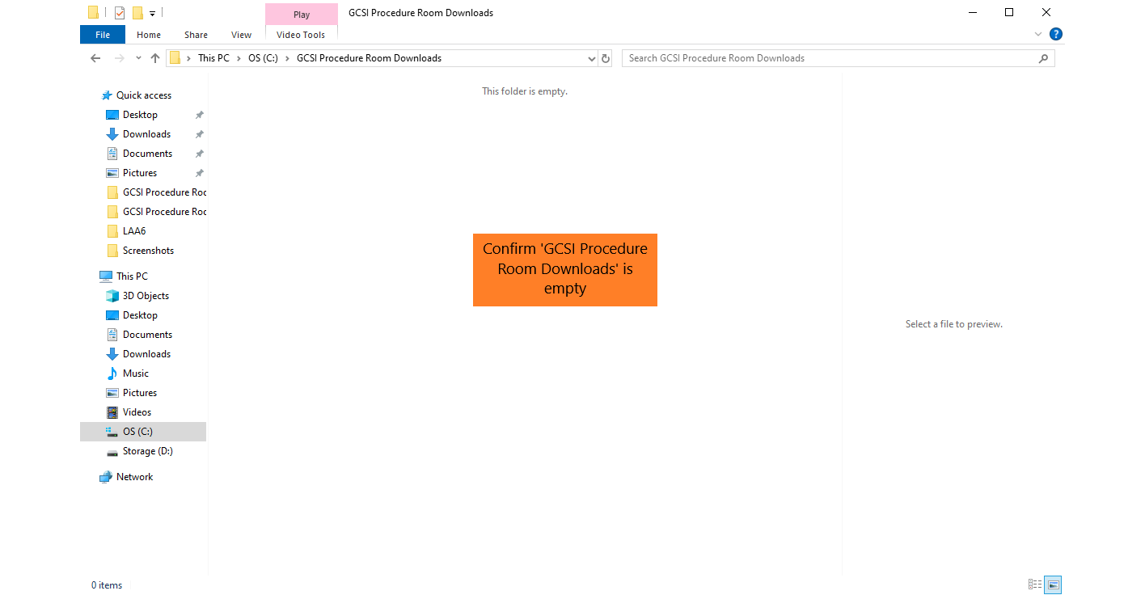

*Figure 49*: Confirm original student recordings have been deleted from “GCSI Procedure Room Downloads” folder

1. Open “C:\Encrypted GCSI Procedure Room Downloads” to unzip encrypted files.
   1. Right click encrypted files -> Show more options (only on Windows 11) -> 7-Zip -> Extract Here -> enter password (see Figures 50-52).

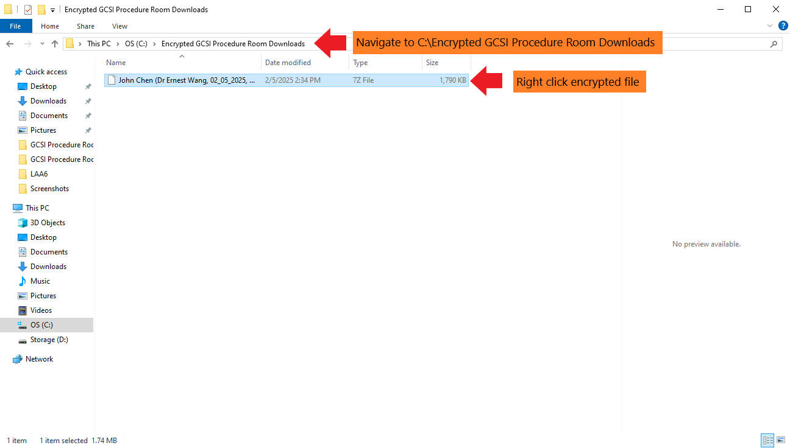

*Figure 50*: Open “C:\Encrypted GCSI Procedure Room Downloads”

*Figure 51*: Extract files using 7-Zip

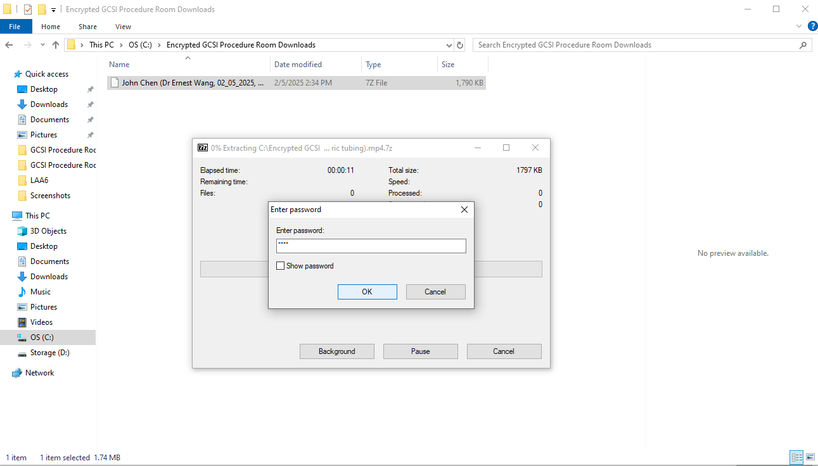

*Figure 52*: Enter encryption password

1. Double-click to open unzipped file (see Figure 53).

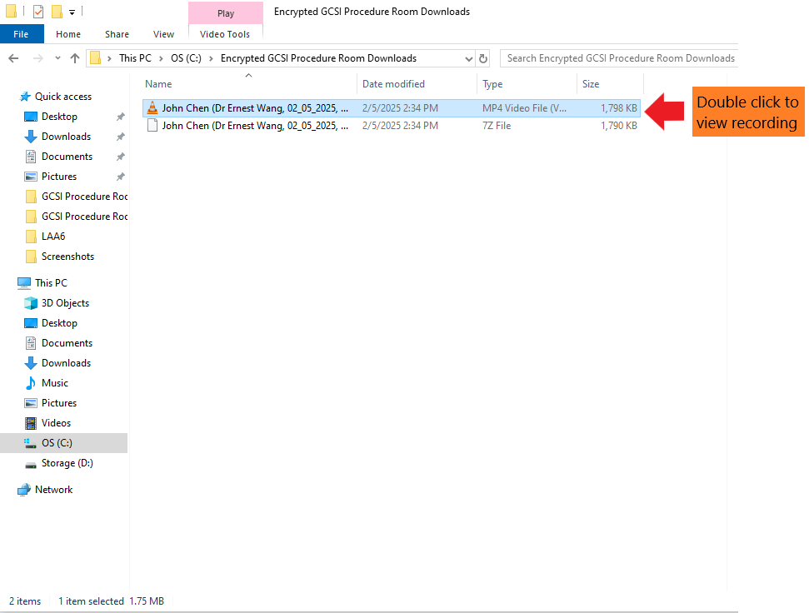

*Figure 53*: Open unzipped file

1. Email .mp4 file to appropriate facilitator.
2. Clear unzipped files from “C:\Encrypted GCSI Procedure Room Downloads”.
3. Close PowerShell window if shutting down computer (can also configure “real_time_encrypt.ps1" PowerShell script to start automatically on boot).

**Administrator - troubleshooting tips:**

* If recordings have no sound, try modifying the “Mic/Auxiliary Audio” in OBS Audio settings
* If recordings have no sound even after modifying the “Mic/Auxiliary Audio” in OBS, try modifying the default microphone in the browser settings
* If PowerShell is throwing an error or video files are not being encrypted, ensure that the folder paths in “real_time_encrypt.ps1” are correct and that all folders being referenced exist

**Students:**

1. Enter information into start page.
2. Set up cameras.
3. Record video on recording page.
4. Upload video.

**Facilitator:**

1. Download .mp4 files from email.
2. To view, open in Windows Media Player, VLC, or browser (Chrome, Edge, etc.).